**Project Report**

**“Zomato Data Analysis”**



CONTENTS

1. **Introduction** 
   1. Zomato ……………………………………………………………04
   2. Insight of Zomato …………………………………………………05
   3. Zomato Gold ………………………………………………………06
   4. Insight of Supplies ………………………………………………...07
   5. Overviews of Zomato……………………………………………...08
   6. Zomato for updating ………………………………………………09
   7. Zomato for Health & Safety ………………………………………10
   8. Data Analysis ……………………………………………………...11
   9. Power BI ………………………………………………………….12

1. **Literature Survey**  
   1. Why is Data Analysis Important…………………………………13
   2. Power BI used for ……………………………………………….14
   3. Scope of Project ………………………………………………....15

1. **System Analysis** 
   1. Import the Dataset ………………………………………………15
   2. Dataset Cleaning ………………………………………………...16
   3. Cleaning Steps ………………………………………………….17
2. **Feasibility Study** 
   1. Data Transformation ……………………………………17
   2. Power Query Editor ……………………………………19

1. **Visualization Charts** ……………………………………….21-35
   1. Stacked Column Chart
   2. Pie Chart
   3. Line Chart
   4. Table
   5. Map
   6. Donut Chart
   7. Stacked Area Chart
   8. Tree Map
   9. Funnel Chart
   10. Slicer
2. **Implementation Phase**
   1. Dashboard …………………………………………….36

1. **Conclusion and discussion** …………………………………39
2. **Links & Barcode** ……………………………………………41
3. **References** ………………………………………………….41



**1. Introduction**

* 1. **Zomato**



**1.2 Insight**



**1.3 Zomato Gold-**



**1.4 Insight of Supplies-**



**1.5 Overviews of Zomato-**



**1.6 Zomato for Updating-**



**1.7 Zomato for Health and Safety--**



**1.8 Data Analysis**

Data analysis is the process of cleaning, changing, and processing raw data and

extracting actionable, relevant information that helps businesses make informed decisions. The procedure helps reduce the risks inherent in decision-making by

providing useful insights and statistics, often presented in charts, images, tables,

and graphs.



**1.9 Power BI**

Power BI is a powerful data visualization and analytics tool that can help you quickly

make sense of your data by extracting it from different data sources.

Power BI is a data visualization platform used primarily for business intelligence

purposes.

Designed to be used by business professionals with varying levels of data

knowledge, Power

BI’s dashboard is capable of reporting and visualizing data in a wide range of

different styles, including graphs, maps, charts, scatter plots, and more.

1. **LITRATURE SURVEY** 
   1. **Why is Data Analysis Important**

**Better Customer Targeting:** You don’t want to waste your business’s precious time,

resources, and money putting together advertising campaigns targeted at

demographic groups that have little to no interest in the goods and services you offer.

Data analysis helps you see where you should be focusing your advertising and

marketing efforts.

**• Reduce Operational Costs:** Data analysis shows you which areas in your business

need more resources and money, and which areas are not producing and thus should

be scaled back or eliminated outright.

• **Better Problem-Solving Methods:** Informed decisions are more likely to be

successful decisions. Data provides businesses with information. You can see where

this progression is leading. Data analysis helps businesses make the right choices

and avoid costly pitfalls.

• **You Get More Accurate Data:** If you want to make informed decisions, you need

data, but there’s more to it. The data in question must be accurate. Data analysis

helps businesses acquire relevant, accurate information, suitable for developing

future marketing strategies, business plans, and realigning the company’s vision or

mission

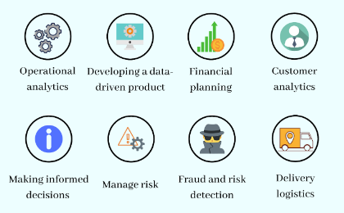

**2.2 Power BI used for**

Whether you’re a data pro or are just entering the business world, Power BI is

designed to empower you with data-driven insights. Some of the most common uses

for the platform include:

• Creating reports and dashboards that present data sets in multiple ways using

visuals

• Connecting various data sources, such as Excel sheets, onsite data warehouses, and

cloud-based data storage, and then transforming them into business insights

• Turning data into a wide range of different visuals, including pie charts,

decomposition trees, gauge charts, KPIs, combo charts, bar and column charts, and

ribbon charts – among many other options

• Providing company-wide access to data, data visualization tools, and insights in

order to create a data-driven work culture

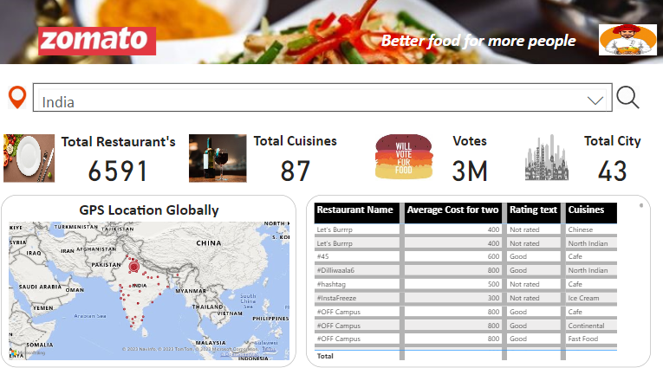

**2.3 Scope of Project**

The project involves a comprehensive analysis of Zomato, focusing on various

dimensions to gain insights into the company's performance, market presence, and

customer engagement. Key areas of examination include Zomato's business model,

financial health, market position, technological infrastructure, regional presence,

and strategic initiatives. The analysis will be presented through graphs and visual

representations for a clear and concise understanding.

1. **SYSTEM ANALYSIS** 
   1. **Import the Dataset**

Initially, we identify the type of data we are working with, such as Excel data, SQL

Server data, web data, or Power BI datasets. Once determined, we proceed to load

and transform the data, initiating the cleaning process as the first step.

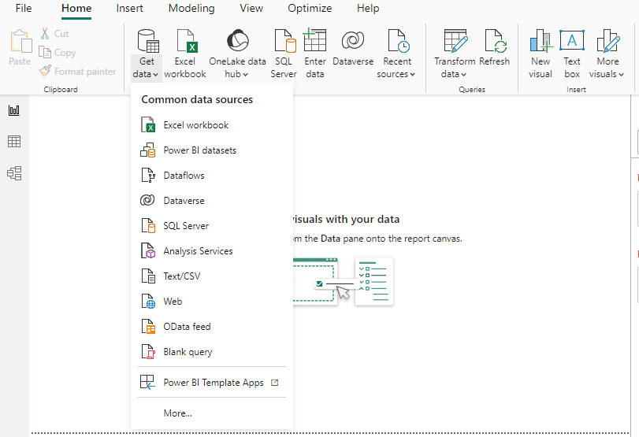

**3.2 Dataset Cleaning**

There are some steps we use to clean data in Power BI, which are helpful in creating meaningful insights.

1. Use the first row as a header.

2. Remove duplicate rows.

3. Remove duplicate and null columns.

4. Remove blank rows.

5. Check for null and blank values; if they exist, delete them.

6. Check data types; always convert numerical values into decimal or fixed decimal values.

7. Check date data types and convert them into the US and UK time zones using their respective locales because sometime data are in the United States right

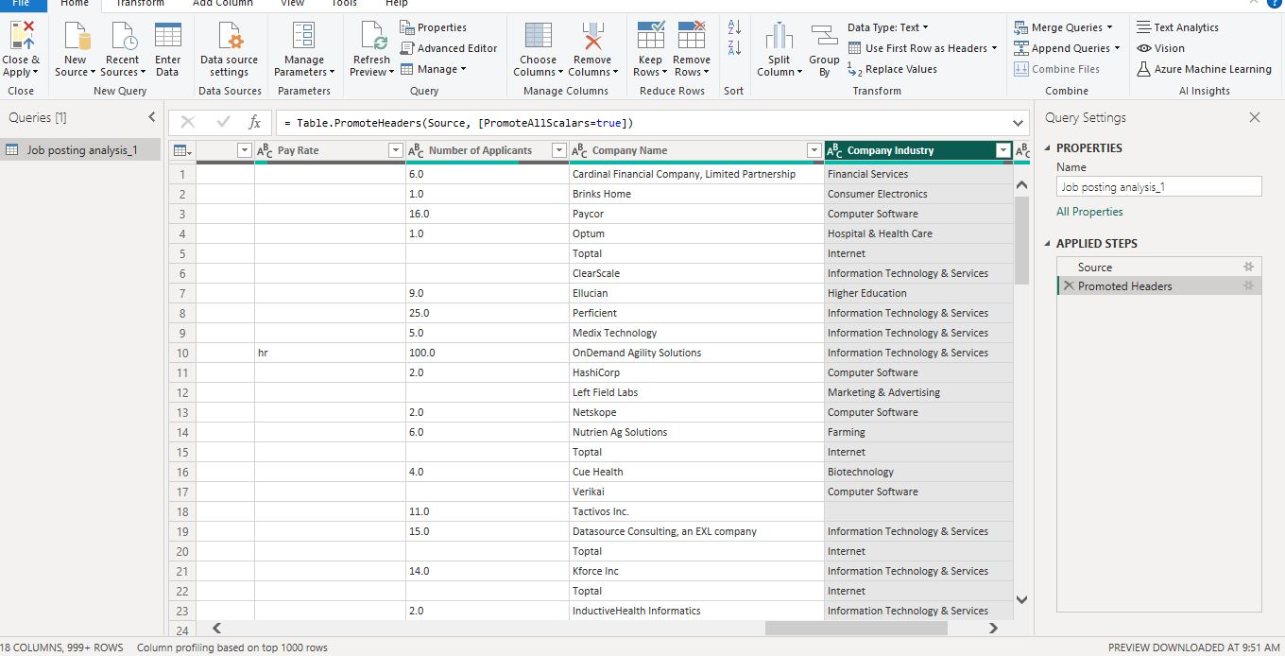

**3.3 Cleaning Steps**

Here, I commence the cleaning process for Zomato data. The initial steps include:

1. Using the first row as the header.

2. Renaming the default column index as 'Unnamed', as Promoted Headers

3. In Restaurant’s column have alphabetic values so, remove this value.

3. Splits 'Cuisines' and unpivot this column

4. Match the data types of both the two table of country columns behalf of this it maintains relationship between the tables.

5. Checking for null and blank values and deleting them if they exist

And Rating color column also have numerical values then remove it.

6. Converting the data types of each column; numerical values default to decimals, and dates

are adjusted to their local zones, such as US and UK.

7. For this H1B dataset, I created a duplicate column for 'Worksite' and subsequently split the states and cities.

Following these steps, I close and apply the transformed dataset, where I proceed to conduct insightful analysis.

1. **Feasibility**

**4.1 Data Transformation:**

**Power BI Desktop has three views**:

**Report view** – You can use queries that you create to build compelling visualizations, arranged as you want them to appear, and with multiple pages, that you can share with others.

**Table view** – See the data in your report in data model format, where you can add measures, create new columns, and manage relationships.

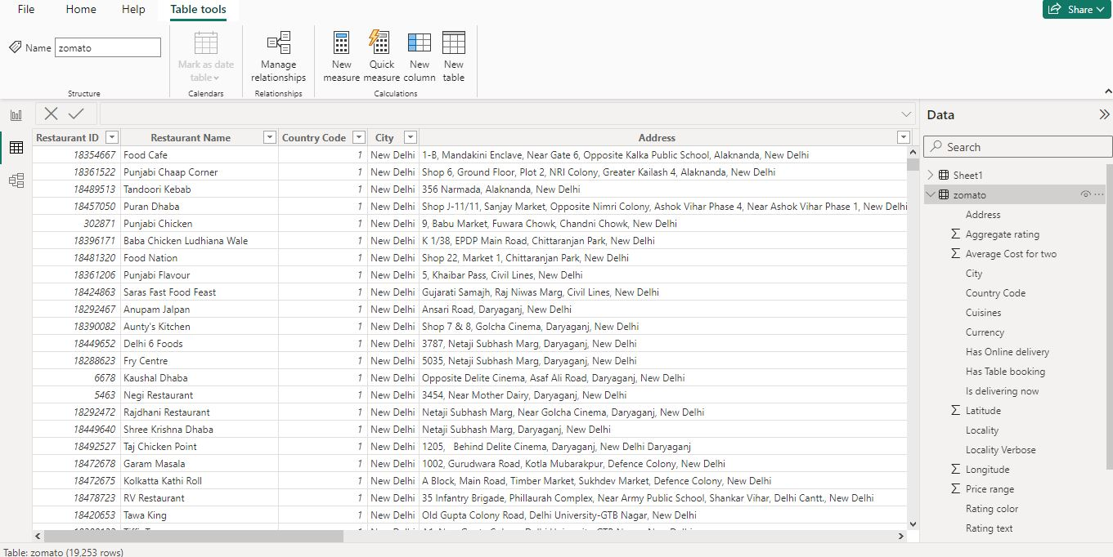

**Model view** – Get a graphical representation of the relationships that are established in your data model, and manage or modify them as needed.

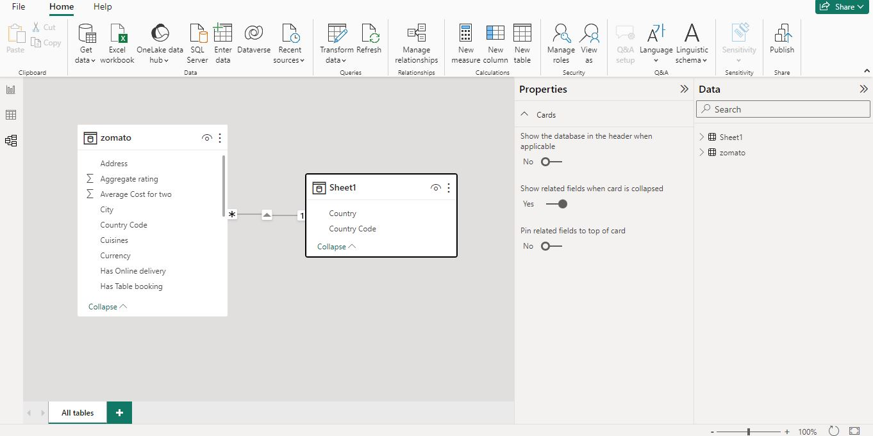

Access these views by selecting one of the three icons along the left side of Power BI Desktop. In the following image, Report view is selected, indicated by the yellow band beside the icon.

Power BI Desktop also comes with Power Query Editor. Use Power Query Editor to connect to one or many data sources, shape and transform the data to meet your needs, then load that model into Power BI Desktop.

**4.2 Power Query Editor**

To get to Power Query Editor, select Transform data from the Home tab of Power BI Desktop.

With no data connections, Power Query Editor appears as a blank pane, ready for data.

After a query is loaded, Power Query Editor view becomes more interesting. If you connect to a Web data source using the New Source button in the top left, Power Query Editor loads information about the data, which you can then begin to shape.

To connect to data and begin the query building process, select New Source. A menu appears, providing the most common data sources.

**Advanced Editor**

The Advanced Editor lets you see the code that Power Query Editor is creating with each step. It also lets you create your own code in the Power Query M formula language. To launch the advanced editor, select View from the ribbon, then select Advanced Editor. A window appears, showing the code generated for the selected query.

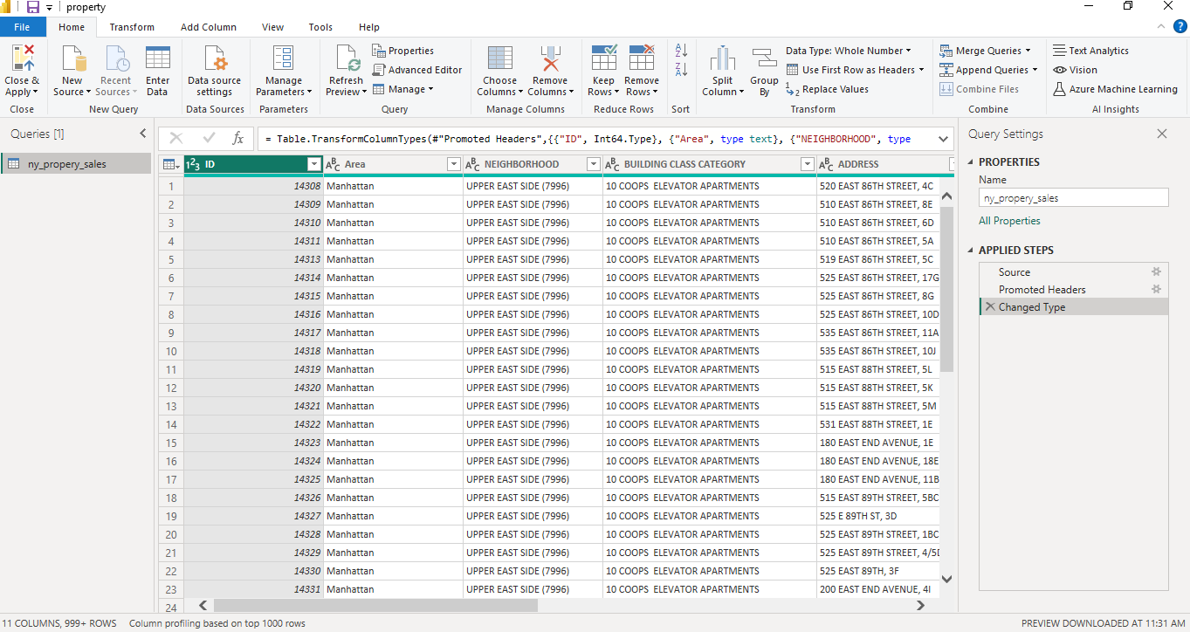

1. **Visualizations**

**5.1 Stacked Column Chart & Stacked Bar Chart**

Both are most usable visuals in Power BI. Stacked Column Chart is useful to compare multiple dimensions against a single measure. In a stacked column chart, the vertical axis represents the numerical values of the data, while the horizontal axis displays the categories or time periods.

Stacked column charts are useful for comparing the total values of different groups, as well as for identifying the contribution of each group to the overall total.

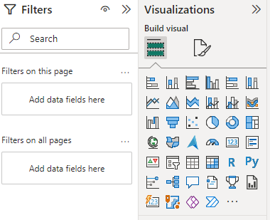

**How to formatting Stacked bar Chart?**

**Visual Tab:**

**X-axis :** Mange the X-axis Value font size, color, Title and Display Unit etc.

**Y-axis:** Mange the Y-axis Value font size, color and Title.

**Legend:** Specified the Legend Text color, font size, Position & Title.

**Bars:** Change the color of chart & maintain the spacing between bars.

**Data Labels:** Enable the data labels on chart, manage the display unit of labels.

**Total Labels:** Enable Total labels on chart.

**General Tab:**

Properties: In this section you can manage the chart height, width, horizontal & vertical position.

**Title:** Under general tab you can see the title section> Here you can set the below properties-

**Title-** Specified the title for chart, & manage the font size, color, background for chart.

**Subtitle-** Specified the subtitle for chart, & manage the font size, color, background for chart.

**Divider-** Enable the line between Title & chart.

**Spacing-** Manage the space between title, Subtitle & chart area.

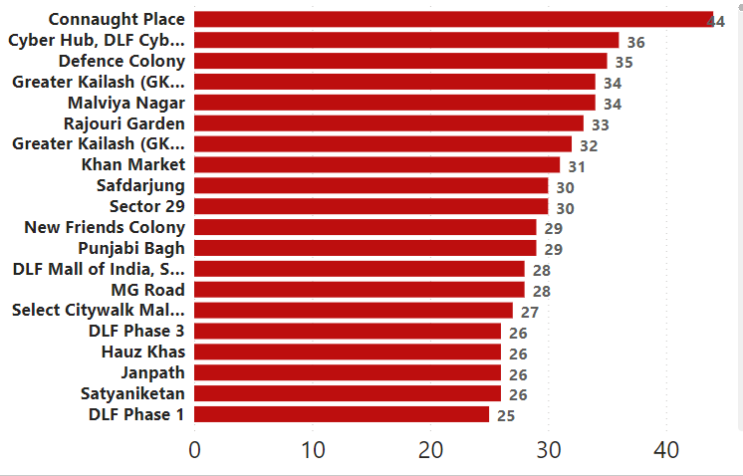

**Key features of a Stacked Bar Chart in Power BI include:**

* **Multiple Categories:** Each bar on the chart represents a specific category, and the individual segments within the bar represent the subcategories or components.
* **Stacked Segments:** Subcategories are stacked on top of each other within a single bar, illustrating the contribution of each subcategory to the total of that category. o
* **Comparison and Composition:** Stacked bar charts allow you to compare both the overall distribution of categories and the distribution of subcategories within each category.
* **Color Coding:** Different subcategories are typically assigned distinct colors to aid in differentiation.
* **Legend:** The legend helps identify the subcategories and their colors.
* **Tooltip:** Hovering over a segment provides detailed information about the value it represents

**5.2 Pie Chart in Power BI**

Pie Chart in Power BI is a built-in visualization chart available with all versions of Power BI. The pie chart is a round-shaped circle chart where each category data set is shown in a pie shape based on the value of each data label. In addition, the pie chart of each category is adjusted against the overall portion of the data labels.

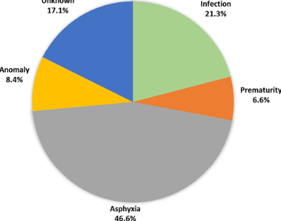

**Legend:** This is nothing based on what column values we need to see the pie chart. In our example, we need to see the “Region-wise” pie chart. Our legend will be the “Region” column from “Pie Table.”

**Details:** If you want to show any further partition of the data you can add here, we will come back to this in the second example.

**Values:** This is nothing but what numerical value we need to show in the pie circle.

**Tooltips:** This is nothing but adding an extra element to the pie chart when we hover on any of the slices of the pie.

**5.3 Line Chart in Power BI**

A line chart is a sequence of data points defined by dots and joined by straight lines. A line chart may include one or multiple lines. It is one of the visuals to display the data in the Power BI report in a visually immersive and interactive manner.

It is used to define continuous data sets and the line charts maintain an X and a Y-axis in Power BI.

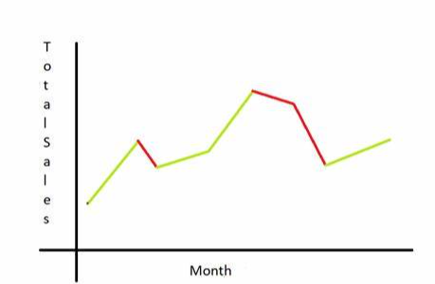

**Multiple lines on a Line chart in Power BI**

Let us see how to display multiple lines plotted on a Line Chart visual in Power BI,

Yes, it is possible to display the line chart with multiple lines plotted on it.

**To achieve this, follow the below steps:**

* Initially, make sure that you have loaded the data source to the Power BI desktop.
* Once the data is loaded you can confirm the data under the Fields section and the fields pane contains the column data presented in the source data.
* Now under the Visualizations pane, select the Line Chart option, you can see that the line chart is added to the report canvas.

**5.4 Tables in Power BI reports**

A table is a grid that contains related data in a logical series of rows and columns. A table can also contain headers and a row for totals. Tables work well with quantitative comparisons where you're looking at many values for a single category. In the following example, the table displays five different measures for the Category items, including average prices, year over year sales, and sales goals.

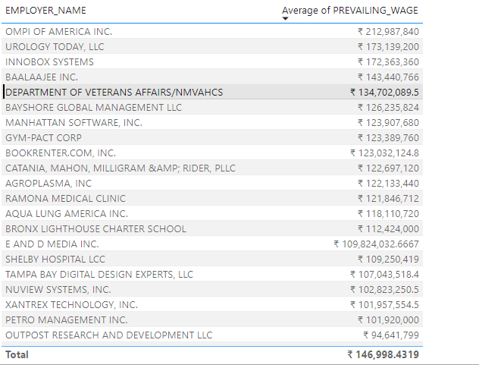

Power BI helps you create tables in reports and cross-highlight elements within the table with other visuals on the same report page. You can select rows, columns, and even individual cells, and then cross-highlight the values. You can also copy and paste individual cells and multiple cell selections into other applications.

When to use a table

Tables are a great choice for several scenarios:

Represent numerical data by category with multiple measures.

Display data as a matrix or in a tabular format with rows and columns.

Review and compare detailed data and exact values rather than visual representations.

**5.5 Map visualization**

The map visualization in Power BI is a useful tool for analyzing spatial data. It allows you to create a map that represents your data in a way that is easy to understand and visually compelling. The map visualization works by integrating with Bing Maps, which provides a rich set of map styles and geographic data.

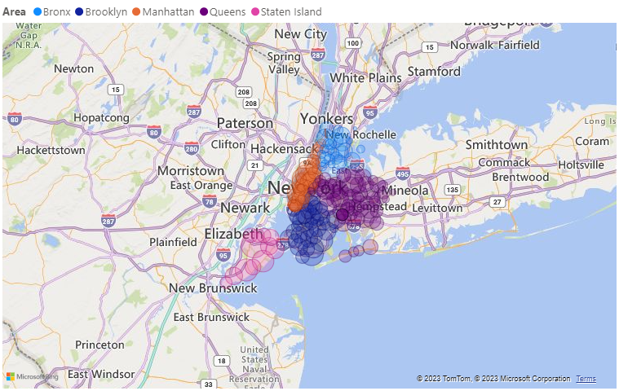

The map visualization gives you the ability to add multiple layers and data points to your map, customize the map's appearance, and create drill-down hierarchies for deeper analysis.

One of the key features of the map visualization in Power BI is the ability to use custom map layers.

This means that you can import your own geographic data, Additionally, the map visualization supports a wide range of data types, including latitude and longitude coordinates, addresses, and even postal codes, making it a versatile tool for spatial analysis.

1**. Categorize geographic fields**

In Power BI Desktop, you can ensure fields are correctly geo-coded by setting the Data Category on the data fields. In Data view, select the desired column. From the ribbon, select the Column tools tab and then set the Data Category to Address, City, Continent, Country, County, Postal Code, State, or Province.

**2. Use more than one location column**

Sometimes, even setting the data categories for mapping isn't enough for Bing to correctly guess your intent. Some designations are ambiguous because the location exists in multiple countries/regions. For example, there's a Southampton in England, Pennsylvania, and New York.

**3. Use specific Latitude and Longitude**

Add latitude and longitude values to your semantic model. This data removes any ambiguity and returns results more quickly. Latitude and Longitude fields must be in Decimal Number format, which you can set in the data model.

**4. Use Place category for columns with full location information**

While we encourage you to use geo-hierarchies in your maps, if you must use a single location column with full geographical information, you can set the data categorization to Place. For example, if the data in your column is full addresses, such as 1 Microsoft Way, Redmond Washington 98052, this generalized data category works best with Bing.

**In Power BI: tips to get better results when using map visualizations**

1. Use latitude and longitude fields (if they exist)

In Power BI, if the semantic model you are using has fields for longitude and latitude--use them! Power BI has special buckets to help make the map data unambiguous. Just drag the field that contains your latitude data into the Visualizations > Latitude area. And do the same for your longitude data. When you add this data, you also need to fill the Location field when creating your visualizations. Otherwise, the data is aggregated by default, so for example, the latitude and longitude would be paired at the state level, not the city level.

**5.6 Donut Chart**

A donut chart is a circular chart, which could present values of a dataset in the form of slices of a donut. The donut chart is exactly the same as a pie chart, the only difference is pie chart has a circle, but a donut chart has a hole in the circle. We have various options to format donut charts, we can change the value of the legends, rotation, detail labels, etc. In this article, we will learn how to format a donut chart in Power BI and explore its various options.

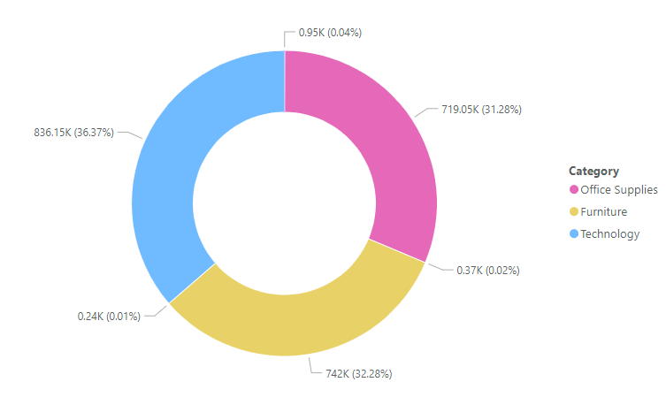

**Formatting a Donut Chart In Power BI**

After the successful, creation of a donut chart in Power BI, we have multiple options to format it. For example, adding the title to the chart, changing the color, and position of the chart, and adding tooltips, slicer colors, and detail labels to the chart.

**5.7 Stacked Area Chart**

A stacked area chart is formed by combining the line chart, with the shaded area under that line. This chart is generally, used when we want to see the trends, that which field is performing better, in a particular time frame. For example, considering the stock prices of different companies, in the past 5 months, then a stacked area chart can be very useful, to see this trend. In this article, we will learn how to create a stacked area chart in Power BI.

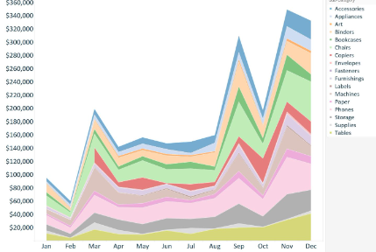

**Creating a Stacked Area Chart**

A Stacked Area chart has multiple options while creating, and customizing it. We will take a look at each of the options. For example, we are given a data set of Employees, and we want to make a Stack Area chart, consisting of legends, and small multiples, segregated by year. We will explore each option while creating this stacked area chart.

**5.8 Tree Map**

TreeMap in Power BI is the hierarchical chart, which is used to show the parent and child data distribution. TreeMap is shown by a group of rectangles, these rectangles are segregated on the basis of the category. The larger numeric values are present at the top, and lower numeric values are present at the bottom. In this article, we will learn how to create a TreeMap in Power BI using steps.

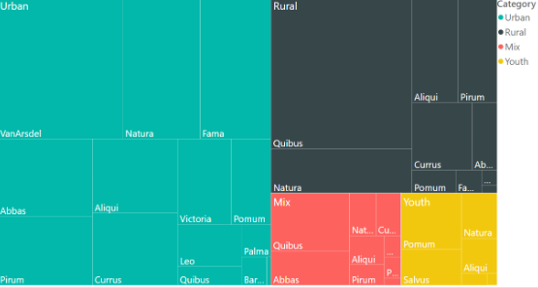

**Loading Dataset for a TreeMap**

When generating and designing a treemap, there are several options available. We’ll examine all of the possibilities. We will use a given dataset of employees, for instance, we could wish to create a treemap with the following categories: Department, Details, Employee Name, Values, and Bonus. While building this treemap, we will investigate each possibility.

**5.9 Funnel Chart**

A Funnel Chart is a type of chart that is used to represent how the data moves through a process or system. It shows how data flows throughout all the stages of some process which is easy to read and understand. It represents a Linear process with sequential and connected stages.

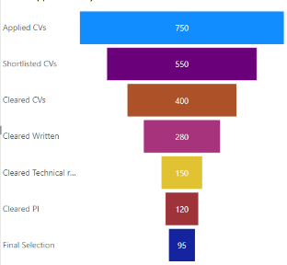

A Funnel chart looks like a broad head and narrow neck at the bottom showing some data flow in a chart. Funnel charts are widely used to represent the sales funnels, recruitment process, and item order fulfillment process which means multiple stages of a whole long process.

**5.10 Slicer**

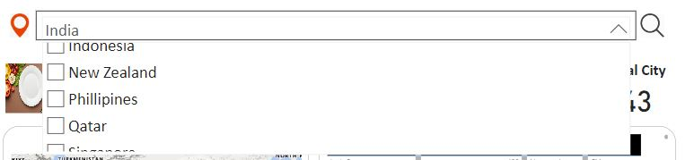

Suppose you want your report readers to be able to look at overall sales metrics,

but also highlight performance for individual district managers and different time

frames. You could create separate reports or comparative charts. You could add

filters in the Filters pane. Or you could use slicers. Slicers are another way of

filtering. They're displayed on the report page, and narrow the portion of the

semantic model that's shown in the other report visualizations.

This article walks through creating and formatting a basic slicer, using the free Retail Analysis Sample. It also covers controlling which visuals are affected by a slicer, syncing with slicers on other pages, and filtering and formatting slicers.

**These other articles explain how to make specific types of slicers:**

**Numeric range slicers.**

**Relative date slicers.**

**Relative time slicers.**

**Responsive, resizable slicers.**

**Hierarchy slicers with multiple fields.**

When to use a slicer

Slicers are a great choice when you want to:

Display commonly used or important filters on the report canvas for easier access.

Make it easier to see the current filtered state without having to open a drop-down list.

Filter by columns that are unneeded and hidden in the data tables.

Create more focused reports by putting slicers next to important visuals.

**6. Implementation Phase**:

**6.1 Dashboard:**

**Here it is three pages are:**

1. **Home**
2. **Insight**
3. **Top Restaurant’s**
4. **Cost & Rating**
5. **Restaurant’s Selection**
6. **Home**

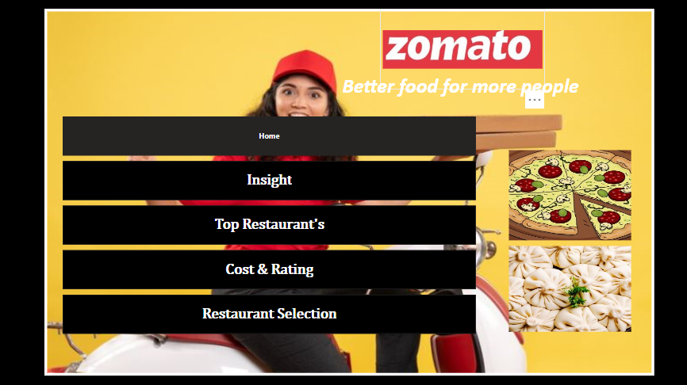

1. **Insight**

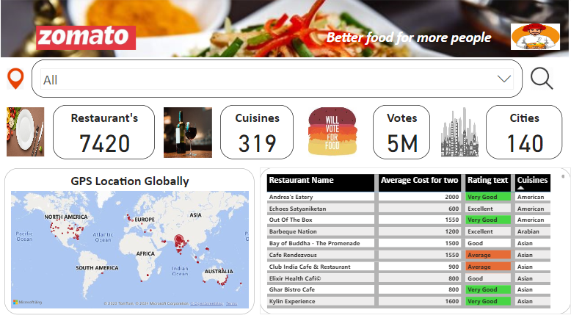

1. **Top Restaurant’s**

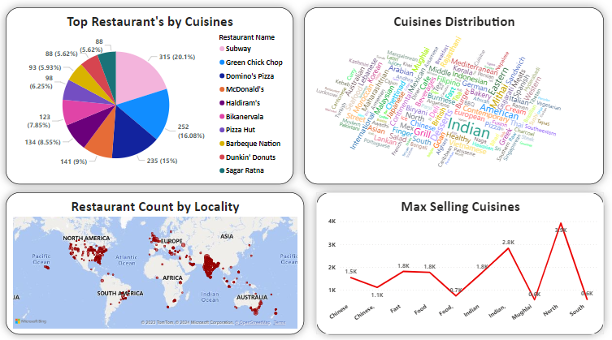

1. **Cost & Rating**

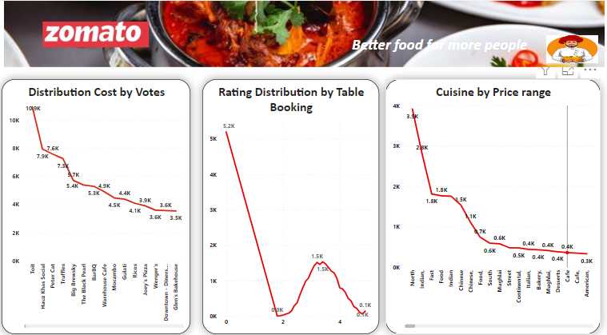

1. **Restaurant’s Selection**

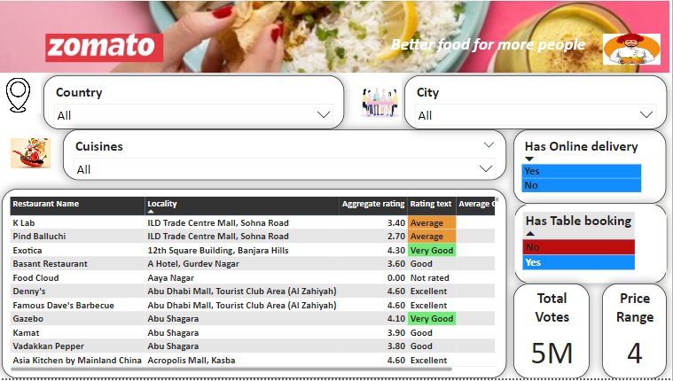

1. **Conclusion and discussion**

* **Homepage Navigation:**

Home

Insights

Top Restaurants

Cost & Rating

Restaurant Selection

Insights Page:

* **Utilizing a slicer for country search, this page showcases:**

Total restaurants globally

Total cuisines worldwide

Total votes received

Total cities covered

Global locations

Restaurants sorted by rating

* **Top Restaurants:**

Top restaurants categorized by cuisines

Leading cuisines in specific locations

Distribution of cuisines

Most popular cuisines

Restaurant counts by locality

* **Cost & Rating:**

Distribution of costs based on votes

Rating distribution related to table bookings

Cuisines categorized by price range

Rating distributions influenced by online orders

* **Restaurant Selection:**

Options for country and city selection, with details on:

Availability of online delivery

Table booking options

Total votes received

Price range

Comprehensive restaurant details, including name, locality, aggregate rating, rating text, and average cost for two.

1. **Links & Barcode**

**Here are the deployment links for the Power BI project:**

**Links:**

https://app.powerbi.com/Redirect?action=OpenReport&appId=a6866d39-b5fa-4354-a08e-a842aaf92c32&reportObjectId=7757c552-1e40-4605-a60a-4202ae4edb94&ctid=c3e8fb7a-11a9-4a44-a1b4-1dda7786becf&pbi_source=appShareLink&portalSessionId=ad1da553-296b-437b-8b5a-818d5b3ec6ac

**App Creations-**

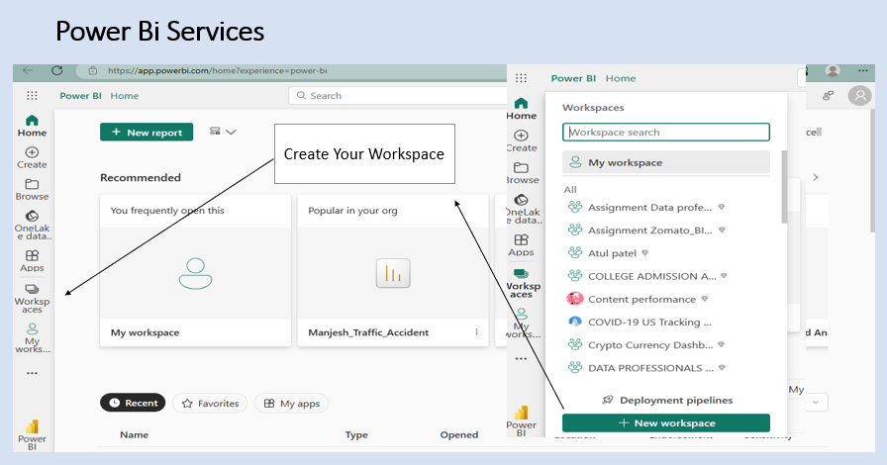

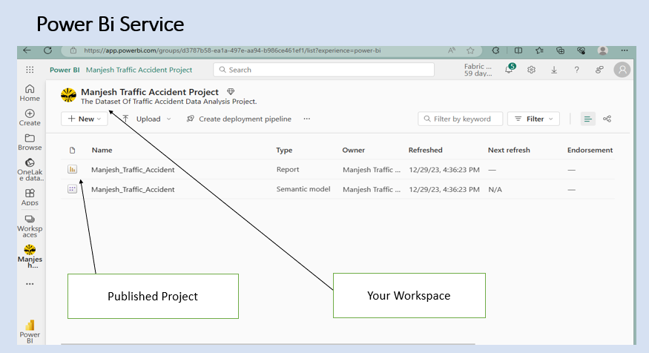

Your Workspace

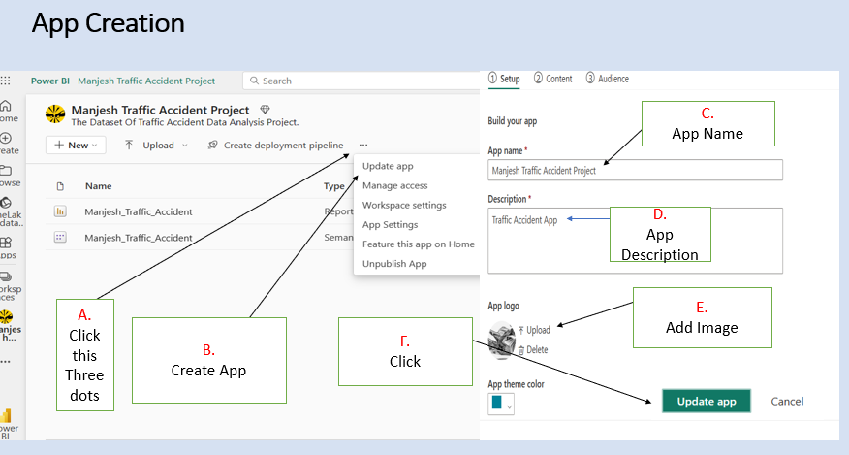

Workspace

**Barcode: Here Scan the barcode below to access and view the project.**



1. **References**

**Links:**

[Power BI documentation - Power BI | Microsoft Learn](https://learn.microsoft.com/en-us/power-bi/)